Data Analytics Capstone
An AI-Assisted Decision Support Framework for Identifying and Prioritizing Healthcare Infrastructure Gaps Across Indian Districts
Capstone Report
Harathi Anirudh
Walsh College
QM640: Data Analytics Capstone
Kartik Umesh
Summer Term 2026
14-September-2026

Table of Contents
Abstract 1
Introduction 2
Problem Statement 3
Purpose of the Study 4
Scope of the Study 5
Aim and Objectives 6
Aim 6
Research Objectives 6
Research Questions 6
Research Hypothesis 7
Sample Size / Power Analysis 9
Hypotheses Testing and Evidence Summary 10
Literature Survey 11
Literature Review Approach 11
Key Literature and Relevance 11
Literature Relevance to the Research Questions 13
Research Gap 13
Data Description and Sources 14
Overview of Datasets 14
Rural Health Statistics (RHS) 14
Census of India 2011 16
National Family Health Survey (NFHS-5) 17
Integrated Analytical Dataset 18
Data Dictionary 20
Project Repository 21
Research Methodology 22
Research Design 22
Data Preparation and Integration 23
Exploratory Data Analysis (EDA) 24
Construction of Healthcare Infrastructure Gap Index (HIGI) 24
Statistical Analysis 25
Research Framework and Architecture Diagram 25
AI and Machine Learning Methodology 26
Evaluation and Validation 27
Mapping of Research Questions to Analytical Approach 28
Analysis 30
Data Cleaning 30
Exploratory Data Analysis 31
Health Infrastructure Gap Index (HIGI) 36
HIGI Validation and Health Outcome Associations 37
District Clustering: RQ3 38
Predictive Modelling 38
AI-Assisted District Prioritization: RQ4 40
Summary of Results by Research Question 41
Recommendation and Application 41
Significance of the study 44
Limitations of the Study 44
Conclusion 46
References 47

List of Table’s
Table 1: Sample Size Adequacy by Research Question 9
Table 2: Hypothesis Testing and Analytical Evidence Summary 10
Table 3: Overview of source Datasets 14
Table 4: Rural Health Statistics (RHS) Dataset Summary 15
Table 5: Selected RHS Variables 15
Table 6: Census of India 2011 Dataset Summary 16
Table 7: Selected Census Variables 16
Table 8: National Family Health Survey (NFHS-5) Dataset Summary 17
Table 9: Selected NFHS-5 Variables 18
Table 10: Categories of Variables in the Integrated Dataset 19
Table 11: Integration Summary 20
Table 12: Data Dictionary of the Integrated Analytical Dataset 20
Table 13: Data Cleaning Summary 23
Table 14: Machine Learning Models and Their Purpose 27
Table 15: Evaluation Metrics Used in the Study 27
Table 16: Mapping of Research Questions to Analytical Approach 28
Table 17: Data Cleaning Summary 30
Table 18: Missing Value Assessment 30
Table 19: Top 10 Districts with Largest Infrastructure Gaps 36
Table 20: Bottom 10 Districts with Smallest Infrastructure Gaps 37
Table 21: Spearman Correlation of HIGI with Selected Health Outcome Indicators 37
Table 22: Cluster Validation Results 38
Table 23: Model Performance Comparison 39
Table 24: Summary of Research Findings 41
Table 25: Risks and Mitigation 43

List Of Figures
Figure 1: Architecture of AI-assisted Healthcare Infrastructure Gap Decision-Support Framework 26
Figure 2: Distribution of Healthcare Infrastructure Variables 32
Figure 3: Distribution of Demographic Variables 33
Figure 4: Distribution of Health Outcome Variables 34
Figure 5: Correlation Matrix of the Integrated Analytical Dataset 35
Figure 6:PCA Visualization of District Profiles Based on Healthcare, Demographic and Health Indicators 38
Figure 7: Random Forest Feature Importance 39
Figure 8: Comparison of Conventional HIGI and AI-Assisted District Prioritization 40

Abstract
Healthcare infrastructure availability varies widely across the districts in India. There is a challenge to identify and prioritize districts that require more attention in terms of infrastructure. In this work, we develop and test a data-driven decision support framework, aided by AI, for district-level healthcare infrastructure evaluation and prioritization. We created a harmonized analytical dataset of 488 districts and 18 features related to healthcare infrastructure, demographic characteristics and health outcomes using publicly available data from the Rural Health Statistics (RHS), Census 2011 and the National Family Health Survey (NFHS-5). For a standardized measure of relative infrastructure gaps, a Healthcare Infrastructure Gap Index (HIGI) was constructed based on five population-normalized healthcare infrastructure indicators. After that, K-Means clustering was used to extract district profiles based on healthcare, demographic, and health characteristics. Random Forest regression was used to provide a complementary predictive perspective for HIGI-based prioritization. The HIGI values ranged from 0.0861 to 0.9765 and were associated with selected health outcome indicators. Three district profiles were identified with a Silhouette Score 0.2018 and DBI of 1.6442, indicating useful but moderately separated analytical profiles. The Random Forest model yielded a test R squared of 0.7092 with an MAE of 0.0524 and an RMSE of 0.0770. The observed HIGI and out-of-fold AI-assisted rankings had a Spearman value of .653 (p < 0.001) with 10% overlap in the top 20 districts. The findings suggest that integrated analytics, composite indicators, clustering and machine learning can serve as complementary evidence for planning of healthcare infrastructure at district-level. The framework is designed as a decision support tool, with ultimate prioritization depending on policy, budgetary, feasibility, geographic, staffing and expert considerations.

Introduction
Health system infrastructure is an important determinant of equal access to health services. In India, there exist huge disparities in the availability of primary, secondary and district level healthcare facilities across districts, which are driven by differences in population size, demographic composition and health status (Sharma et al., 2019). Such differences pose challenges for policymakers seeking to identify which districts should always be prioritized for infrastructure investment.
India has a plethora of publicly available data on health care infrastructure, demographics and health outcomes through sources like RHS, Census 2011 and NFHS-5. However, these datasets measure different aspects of the health care system and are often analyzed separately. Integrated analytical approach could give a more comprehensive basis for the evaluation of infrastructure gaps and identification of priority districts.
This study develops an AI-assisted decision support framework that integrates district-level health infrastructure, demographic, and health outcome data. The framework builds a Healthcare Infrastructure Gap Index (HIGI) to quantify the relative infrastructure gaps, uses clustering to identify districts with similar healthcare profiles and uses machine learning to add a predictive perspective for district prioritization.
The study’s aim is to offer decision-support, not a replacement for policy or expert judgment. The aim is to create a clear, evidence-based basis for comparing districts, highlighting areas needing more focus and promoting more consistent planning of health infrastructure and allocation of resources.

Problem Statement
India has made great progress in expanding its public healthcare system by investing in primary, secondary and tertiary healthcare facilities. However, there is still a huge disparity among districts in the health infrastructure leading to disparity in access to health care. Disparities in the availability of PHCs, CHCs, hospitals and other facilities, and in population characteristics and health outcomes, hamper the identification of districts that need priority infrastructure investment.
A large amount of data on health and demographics is provided by Government sources. NFHS-5, Census 2011 and RHS. However, these datasets capture different aspects of the healthcare system and are often analyzed independently. An integrated, data-driven approach that combines these dimensions is needed to provide a more objective basis for assessing and prioritizing district-level healthcare infrastructure.
This study contributes to this problem by combining the district level healthcare infrastructure, demographic and health outcome data and creating a Healthcare Infrastructure Gap Index (HIGI), a measure of relative infrastructure gaps across districts. Furthermore, machine learning techniques are applied to detect clusters of districts with similar characteristics and to provide an additional perspective for prediction toward prioritization. The framework is intended to support transparent and evidence-informed planning and allocation of resources for health care infrastructure. The framework is intended as a complement, not a substitute, for policy and expert judgment.

Purpose of the Study
The goal of this study is to design and asses a data-driven AI-assisted decision-support framework for identification and prioritization of gaps in healthcare infrastructure across Indian districts. The framework combines publicly available district level health infrastructure, demographic and health outcome data from official Government of India sources.
The study suggests the Healthcare Infrastructure Gap Index (HIGI) for quantifying and comparing relative infrastructure gaps between districts. The study uses statistical and machine learning methods to identify district profiles and provide an alternative predictive perspective for prioritization.
The framework developed is designed to provide policymakers and healthcare administrators with an objective, transparent and interpretable basis to assess infrastructure disparities and to support healthcare planning and resource allocation. It is intended to complement existing planning processes and expert judgment rather than replace them.

Scope of the Study
The study is concerned the evaluation of the differences in the public healthcare infrastructure at the district level in India using secondary data collected from official sources of Government of India.
The analysis combines the three datasets to study healthcare infrastructure, demographic characteristics and selected health outcomes.
The study covers the following:
- Integration and harmonization of district-level RHS, Census 2011, and NFHS-5 datasets.
- Construction of the Healthcare Infrastructure Gap Index (HIGI) using selected healthcare infrastructure indicators.
- Analysis of demographic and health outcome characteristics associated with district-level infrastructure gaps.
- Identification of district profiles using clustering techniques.
- Application of machine learning to provide an additional perspective on district-level prioritization.
- Development of an AI-assisted decision-support approach for healthcare infrastructure planning and resource allocation.
The analysis is limited to publicly available, district-level data and does not include individual patient records, electronic medical records, real-time healthcare surveillance, private healthcare infrastructure, or detailed economic feasibility and cost-benefit analysis of infrastructure investments. The resulting framework is intended to support, rather than replace, policy decisions and expert judgement.

Aim and Objectives

Aim
The aim of this study is to develop and asses an AI-assisted, data-driven framework that integrates district-level healthcare infrastructure, demographic, and health outcome data to identify, assess, and prioritize healthcare infrastructure gaps across Indian districts.

Research Objectives

Research Objective 1
To develop an integrated district-level analytical dataset by combining healthcare infrastructure, demographic, and health outcome data from RHS, Census 2011, and NFHS-5.

Research Objective 2
To construct the Healthcare Infrastructure Gap Index (HIGI) to measure and compare relative healthcare infrastructure gaps across Indian districts.

Research Objective 3
To apply statistical and ML techniques to identify patterns and groups of districts with similar healthcare infrastructure, demographic characteristics, and health outcomes, and to examine factors associated with variation in healthcare infrastructure gaps.

Research Objective 4
To develop an explainable AI-assisted decision-support approach that provides evidence-based information for district-level healthcare infrastructure prioritization and resource allocation.

Research Questions
This capstone project aims to answer the following research questions:
RQ1. Can district-level healthcare, demographic, and healthcare infrastructure data from official Government of India sources be integrated to effectively quantify healthcare infrastructure gaps across districts?
RQ2. Can a composite Healthcare Infrastructure Gap Index (HIGI) effectively measure and compare the relative healthcare infrastructure gaps among Indian districts?
RQ3. Can Artificial Intelligence and machine learning techniques identify meaningful patterns and group districts based on similarities in healthcare infrastructure, demographic characteristics, and health outcomes?
RQ4. Can an AI-assisted decision-support framework provide a complementary and evidence-based approach to prioritizing districts for healthcare infrastructure investment compared with conventional HIGI-based analysis?

Research Hypothesis
To examine the research questions through statistical analysis, the following null and alternative hypotheses are proposed.
H01
Null Hypothesis (H0₁): There is no meaningful connection between healthcare infrastructure indicators and selected health outcomes across Indian districts.
Alternative Hypothesis (H1₁): Healthcare infrastructure indicators are associated with selected health outcomes across Indian districts.
H02
Null Hypothesis (H0₂): There is no meaningful connection between demographic characteristics and healthcare infrastructure availability across Indian districts.
Alternative Hypothesis (H1₂): Demographic characteristics are associated with healthcare infrastructure availability across Indian districts.
H03
Null Hypothesis (H0₃): Districts do not exhibit meaningful grouping patterns based on healthcare, demographic, and health indicators.
Alternative Hypothesis (H1₃): Districts exhibit meaningful grouping patterns based on healthcare, demographic, and health indicators.
H04
Null Hypothesis (H0₄): AI-assisted prioritization provides no additional prioritization perspective beyond conventional HIGI-based ranking.
Alternative Hypothesis (H1₄): AI-assisted prioritization provides an additional prioritization perspective beyond conventional HIGI-based ranking.

Sample Size / Power Analysis
A sample-size analysis was performed to determine the adequacy of the planned statistical analyzes, as the study uses the entire set of districts available following dataset integration, and not a sample. The final integrated dataset consists of 488 districts, which is more than the minimum requirements estimated for the individual research questions.
Power calculations used an α = 0.05 and a statistical power of 0.80. Where calculations based on effect size were appropriate, a medium effect size was assumed . To address RQ1, a conservative confidence interval approach was used because the question is whether the integrated district-level dataset is adequate, not a test of a specific population parameter.
Table 1: Sample Size Adequacy by Research Question
Research Questions | Method used | Key Parameters | Minimum N | Available N | Adequacy
RQ1 | Confidence Interval | 95% confidence, p = 0.50, margin of error = 5% | 385 | 488 | Adequate
RQ2 | Spearman correlation power analysis | α = 0.05, power = 0.80, medium ρ = 0.30 | 85 | 488 | Adequate
RQ3 | ANOVA-based power proxy for three-group comparison | α = 0.05, power = 0.80, medium effect f = 0.25, 3 groups | 158 | 488 | Adequate
RQ4 | Spearman correlation power analysis | α = 0.05, power = 0.80, medium ρ = 0.30 | 85 | 488 | Adequate

For RQ1, the conservative proportion-based confidence-interval calculation is:
$$n= \frac{Z^{2}*p(1-p)}{e^{2}}$$
Using Z = 1.96, p = 0.50 and e =0.05 we get n = 384.16
Thus, approximately 385 districts are required under this conservative assumption.
For RQ2 and RQ4, the sample size for detecting a medium Spearman correlation of approximately ρ = 0.30 at α = 0.05 and 80% power is approximately 85 observations using a Fisher z transformation.
For RQ3, because unsupervised clustering does not have a direct conventional power-analysis framework, an ANOVA-based three-group comparison was used as a conservative planning proxy. A medium effect size of f = 0.25, α = 0.05, and 80% power gives a minimum requirement of 158 observations.
The largest minimum requirement across the four research questions is therefore 385 districts. The completed analytical dataset contains 488 districts, exceeding this threshold. The available sample is consequently considered adequate for the statistical and machine-learning analyses conducted in this study.

Hypotheses Testing and Evidence Summary
Table 2: Hypothesis Testing and Analytical Evidence Summary
Hypothesis | Analytical Method / Evidence | Result | Interpretation
H01 | Spearman correlation between HIGI and selected health outcomes | Significant associations were observed. Strongest association: Health Insurance, ρ = −0.348; Underweight, ρ = 0.312; Stunting, ρ = 0.260 | Evidence supports H1₁. Healthcare infrastructure gaps are associated with selected health outcomes, although the relationships do not establish causality.
H02 | Correlation analysis between demographic characteristics and infrastructure-related measures | Demographic characteristics showed relationships with variation in healthcare infrastructure gaps | Evidence supports H1₂. Demographic characteristics are associated with infrastructure availability/gaps.
H03 | K-Means with Silhouette Score and DBI | Three district profiles identified; Silhouette = 0.2018; Davies–Bouldin = 1.6442 | Evidence supports H1₃ with qualification. Districts exhibit meaningful analytical grouping, although cluster separation is modest rather than sharply distinct.
H04 | Out-of-fold Random Forest predictions compared with observed HIGI ranking | Spearman ρ = 0.653, p < 0.001; Top-20 overlap = 10% | Evidence supports H1₄. AI-assisted ranking provides an additional and complementary prioritization perspective rather than reproducing the conventional HIGI ranking.

Literature Survey
The literature survey establishes the methodological and domain basis for integrating district-level healthcare data, constructing composite healthcare indices, and applying analytics and machine learning to healthcare planning. The review is focused on literature relevant to the four research questions and to the analytical decisions used in this study.

Literature Review Approach
Relevant literature was identified from academic and institutional sources on assessment of healthcare infrastructure, district-level health-system measurement, composite indicators, machine learning, clustering, and evidence-based healthcare planning. Studies were prioritized if they address district-level healthcare disparities, provide methodological foundations for composite indices and machine learning, or present approaches pertinent to healthcare resource prioritization.
The study relies on existing references that offer a solid base, including work on district-level health-system measurement, composite health indices, composite-indicator methodology, machine learning, and business intelligence. For example, Sharma, Prinja and Aggarwal (2017) examined the measurement of health-system performance at district level, whereas Sharma et al. (2019) developed a composite index for measuring health-system performance in India.

Key Literature and Relevance
District-level healthcare measurement.
The district level measurement is a practical basis for identifying geographical differences in healthcare-system performances. Research on district-level health system measurement has already shown the benefit of multiple indicators over a single one. This supports the study methodology of evaluating healthcare infrastructure through multiple indicators at the district level.
Composite indicators
The composite-indicator method offers a systematic way to combine heterogeneous indicators into one single understandable measure. The methodological basis for indicator selection, normalization, aggregation and interpretation is provided by OECD & JRC, 2008 handbook on constructing composite indicators. This is of direct relevance for the construction of HIGI.
Healthcare indices in India
Recent work on comprehensive health indices in India shows the value of multidimensional indices for examining spatial variation in health care conditions (Sehgal et al., 2024). This is consistent with the aim of the study to generate district level comparative measures as against individual healthcare indicators alone.
Machine learning and analytics
Machine learning methods can detect nonlinear relationships and patterns that may not be apparent from descriptive analysis alone. The analytical foundations of James et al. (2021). and Russell and Norvig (2021) provide a basis for the more general application of statistical learning and AI approaches to structured decision-support problems.
Data sources and healthcare context
The study uses information on infrastructure, demographic and health outcomes from official Indian data sources. NFHS-5 provides district level health indicators, Census 2011 provides demographic information and RHS provides healthcare infrastructure information. The integrated dataset was derived from these sources established by the present study.

Literature Relevance to the Research Questions
Literature/Methodological Area | Relevance to Study | Supports
District-level health-system measurement | Supports multidimensional district comparison | RQ1, RQ2
Composite-indicator methodology | Supports normalization, aggregation, and interpretation of HIGI | RQ2
Indian health indices | Supports multidimensional assessment of regional healthcare variation | RQ2
Statistical learning and machine learning | Supports predictive and pattern-discovery approaches | RQ3, RQ4
Government health and demographic datasets | Supports integration of complementary data dimensions | RQ1
Decision-support and analytics | Supports translation of analytical outputs into planning insights | RQ4

Research Gap
The literature reviewed supports three important elements of this study, namely multidimensional healthcare measurement, composite-index construction, and use of analytics for evidence-based decision making. However, present study brings these together at Indian district level by integrating RHS, Census 2011 and NFHS-5 datasets into a common analytical framework.
The development of a new machine learning algorithm per se is therefore not the novelty of the study. Instead, it is in integrating district-level data integration, HIGI-based infrastructure assessment, district clustering, predictive modeling and AI-assisted prioritization into one decision-support framework.
This provides the basis for a transition from individual healthcare indicators to a more systematic approach to identify and compare districts with different healthcare infrastructure requirements.

Data Description and Sources

Overview of Datasets
This section details the datasets employed in the study, their relevance to the research objectives and the variables chosen for analysis. By using a fusion of multiple government datasets we obtain a holistic picture of healthcare infrastructure availability, demographic characteristics and health outcomes across Indian districts.
Table 3: Overview of source Datasets
Dataset | Source | Granularity | Original Records | Records Used | Purpose
Rural Health Statistics (RHS) | Ministry of Health & Family Welfare | District | 737 | 737 | Healthcare infrastructure
Census 2011 | Office of the Registrar General & Census Commissioner | District | 640 | 640 | Demographic characteristics
National Family Health Survey (NFHS-5) | Ministry of Health & Family Welfare / IIPS | District | 707 | 707 | Health outcome indicators

This study merges three publicly available datasets of the Government of India to develop a comprehensive analytical dataset at the district level to study the disparities in healthcare infrastructure across India.
RHS provides the perspective of health care infrastructure, Census provides the perspective of demographic characteristics and NFHS-5 provides the perspective of health outcome indicators.
The merging of these datasets allows a three dimensional exploration of health care access, population characteristics and health states.

Rural Health Statistics (RHS)
This subsection describes the RHS dataset, its role in the study, and the healthcare infrastructure variables selected for analysis.

Table 4: Rural Health Statistics (RHS) Dataset Summary
Attribute | Description
Dataset | Rural Health Statistics (RHS)
Source | MoHFW, GoI
Granularity | District Level
Original Records | 737 Districts
Records Used | 737 Districts
Role in Study | Provides healthcare infrastructure indicators
RHS is an official publication of Ministry of Health and Family Welfare (MoHFW), GoI, which provides district level information on public health infrastructure in the country. The choice of the dataset is due to the presence of the main indicators of infrastructure, necessary to assess the access to health care and the availability of services at the level of districts.
This study uses the RHS dataset as a main data source to quantify the healthcare infrastructure capacity and is part of the infrastructure component of the Healthcare Infrastructure Gap Index (HIGI).
Table 5: Selected RHS Variables
Variable | Description | Purpose
Sub_Centres | Sub Centre count | Primary healthcare infrastructure
PHCs | Primary Health Centre count | Primary healthcare delivery
CHCs | Community Health Centre count | Secondary healthcare delivery
Sub-Divisional Hospitals | Sub-Divisional Hospitals count | Higher-level healthcare facilities
District Hospitals | District Hospital count | District-level referral hospitals

Only infrastructure-related variables that were directly involved in the assessment of the availability of healthcare facilities were retained. During preprocessing, administrative fields and variables not relevant to the research objectives were deleted.
The selected variables together depict the hierarchical structure of the public healthcare delivery system in India and also provide the infrastructure indicators required for further exploratory analysis and construction of the Healthcare Infrastructure Gap Index (HIGI).

Census of India 2011
This subsection describes the Census 2011 dataset, its contribution to the study, the preprocessing performed to obtain district-level records, and the demographic variables selected for analysis.
Table 6: Census of India 2011 Dataset Summary
Attribute | Description
Dataset | Census 2011
Source | Office of the Registrar General & Census Commissioner, India
Granularity | District Level
Original District Records | 640 Districts
Records Used | 640 Districts
Role in Study | Provides demographic indicators representing healthcare demand
Official national census is the Census 2011, conducted by the office of the Registrar General and Census Commissioner, India. It contains a wealth of demographic, social and economic information at several levels of administration.
For this study, the dataset was preprocessed to include only district level records representing total population . Specifically, the records with Level = DISTRICT and TRU = Total were selected to maintain consistency with the district-level RHS and NFHS-5 datasets. This preprocessing resulted in a standardized demographic dataset ready for integration.
Table 7: Selected Census Variables
Variable | Description | Purpose
TOT_P | Total Population | Represents population size and healthcare demand
P_LIT | Literate Population | Indicates educational attainment within the district
P_ILL | Illiterate Population | Represents the population requiring additional consideration in healthcare accessibility
No_HH | Number of Households | Represents household distribution and population density
The selected demographic variables are proxies of the potential district-level demand for healthcare services. The size of the population requiring health care services is measured by population and household counts, and demographic context that may affect health care awareness, service utilisation and health outcomes is provided by literacy and illiteracy levels.
These variables complement the infrastructure indicators extracted from the RHS dataset and allow for further exploratory analysis and modelling.

National Family Health Survey (NFHS-5)
This subsection describes the NFHS-5 dataset, the health indicators selected for the study, and their relevance to assessing healthcare accessibility and population health outcomes.
Table 8: National Family Health Survey (NFHS-5) Dataset Summary
Attribute | Description
Dataset | NFHS-5
Source | IIPS and MoHFW, GoI
Survey Period | 2019–2021
Granularity | District Level
Original Records | 707 Districts
Records Used | 707 Districts
Role in Study | Provides district-level healthcare utilisation and health outcome indicators

The NFHS-5 is a national level health survey conducted by the International Institute for Population Sciences (IIPS) under of the Ministry of Health and Family Welfare (MoHFW), Government of India. The survey provides detailed district-level data on maternal and child health, nutrition, health care utilization, disease prevalence and health related behaviors.
A subset of health outcome indicators was selected to evaluate access to healthcare, service use and population health for this study. These variables complement the healthcare infrastructure indicators from the RHS dataset and the demographic indicators from the Census dataset to allow for a multidimensional assessment of healthcare disparities across the districts.
Table 9: Selected NFHS-5 Variables
Variable | Description | Purpose
Health_Insurance | % with health coverage | Represents financial access to healthcare
Institutional_Births | % with institutional coverage | Measures utilisation of institutional maternal healthcare services
Skilled_Birth_Attendance | % attended by skilled personnel | Indicates access to skilled maternal healthcare
Full_Immunization | % fully immunized | Measures preventive child healthcare coverage
Stunting | % of children stunted | Indicates chronic child malnutrition
Underweight | % of children underweight | Represents nutritional status for children
Women_Anaemia | % of women with anemia | Indicates women's nutritional and public health status

The selected NFHS-5 variables represent key indicators of healthcare accessibility, service utilisation, and health outcomes. Together, they provide insights into maternal and child health, preventive healthcare coverage, nutritional status, and financial access to healthcare services.
These indicators complement the infrastructure and demographic variables obtained from the RHS and Census datasets, enabling a comprehensive assessment of healthcare disparities across districts.

Integrated Analytical Dataset
The three source datasets were merged to create a harmonized analytical dataset at the district level, suitable for exploring disparities in healthcare infrastructure across India. The datasets came from different governmental sources and had inconsistencies in the naming conventions of the districts and their administrative classifications. Hence, a systematic preprocessing and harmonization process was accomplished before integration.
Data cleaning and harmonization processes were used to standardize district names across all of the datasets. The Census dataset was filtered to retain only district level records representing total population and relevant healthcare infrastructure and health outcome variables were selected from RHS and NFHS-5 datasets respectively. The datasets were preprocessed and merged on the common identifiers of State and District.
The integration process resulted in a consolidated analytical dataset of 488 common districts with 18 variables on healthcare infrastructure, demographic characteristics, and health outcome indicators. All the subsequent exploratory analysis, visualization and the HIGI framework are based on this integrated dataset.
Table 10: Categories of Variables in the Integrated Dataset
Category | Variables | Variable count
Healthcare Infrastructure | Sub Centres, PHCs, CHCs, Sub-Divisional Hospital, District Hospital | 5
Demographic Characteristics | Total Population, Literate Population, Illiterate Population, Number of Households | 4
Health Outcome Indicators | Health Insurance, Institutional Births, Skilled Birth Attendance, Full Immunization, Stunting, Underweight, Women Anaemia | 7
Identifiers | State, District | 2

Table 11: Integration Summary
Item | Value
RHS Records | 737
Census Records | 640
NFHS Records | 707
Final Integrated Dataset | 488 Districts × 18 Variables
The integrated analytical dataset combines complementary infrastructure, demographic, and health outcome indicators into a single district-level dataset, providing a robust and comprehensive foundation for exploratory analysis and modelling framework.

Data Dictionary
This subsection defines the variables retained in the integrated analytical dataset, providing their descriptions, data types, source datasets, and analytical purpose. The data dictionary enhances transparency and reproducibility by documenting the variables used throughout the study.
Table 12: Data Dictionary of the Integrated Analytical Dataset
Variable | Description | Data Type | Source | Analytical Category
State | State or Union Territory | Categorical | Common Identifier | Identifier
District | District Name | Categorical | Common Identifier | Identifier
Sub_Centres | Sub centres count | Numeric | RHS | Healthcare Infrastructure
PHCs | Primary Health Centre count | Numeric | RHS | Healthcare Infrastructure
CHCs | Community Health Centre count | Numeric | RHS | Healthcare Infrastructure
Sub_Divisional_Hospital | Sub-Divisional Hospital count | Numeric | RHS | Healthcare Infrastructure
District_Hospital | District Hospital count | Numeric | RHS | Healthcare Infrastructure
TOT_P | Total Population | Numeric | Census | Demographic
P_LIT | Literate Population | Numeric | Census | Demographic
P_ILL | Illiterate Population | Numeric | Census | Demographic
No_HH | Number of Households | Numeric | Census | Demographic
Health_Insurance | % with health coverage | Numeric | NFHS-5 | Health Outcome
Institutional_Births | % of institutional deliveries | Numeric | NFHS-5 | Health Outcome
Skilled_Birth_Attendance | % attended by skilled personnel | Numeric | NFHS-5 | Health Outcome
Full_Immunization | % immunized | Numeric | NFHS-5 | Health Outcome
Stunting | % children stunted | Numeric | NFHS-5 | Health Outcome
Underweight | % children underweight | Numeric | NFHS-5 | Health Outcome
Women_Anaemia | % women with Anaemia | Numeric | NFHS-5 | Health Outcome

The final integrated dataset consists of 18 features, including 2 identifier variables, 5 healthcare infrastructure variables, 4 demographic variables, and 7 health outcome variables.
These variables collectively represent the multidimensional characteristics required to evaluate healthcare infrastructure disparities and support the exploratory analysis and modelling framework presented in this study.

Project Repository
To promote transparency and reproducibility, all project files developed during this project are stored in a git hub repo. The repository serves as the central location for the analytical workflow, project documentation, and version-controlled source code used throughout the study.
The repository includes:
- Jupyter Notebook containing data preprocessing, integration, exploratory data analysis (EDA), and visualizations.
- All report and supporting documentation.
- Dataset references and project documentation.
- Source code developed during the analytical workflow.
The project repository can be accessed using the following link:
GitHub Repository: https://github.com/Haraani/Healthcare-Infrastructure-Gap-Index

Research Methodology
The project uses a quantitative, data driven research methodology based on secondary datasets available in public domain from official sources of Government of India. The study uses data preparation, statistical analysis and ML techniques to examine inequities in healthcare infrastructure across Indian districts.
The methodology consists of seven continuous stages which are research design, data preparation, exploratory data analysis, Healthcare Infrastructure Gap Index (HIGI) construction, statistical analysis, machine learning analysis, evaluation and validation, and the development of an AI-assisted decision support framework.
The overall methodology comprises seven consecutive stages:
- Research design
- Data preparation
- Healthcare Infrastructure Gap Index (HIGI) construction
- Statistical analysis
- Machine learning analysis
- Evaluation and validation and
- Development of the decision support framework.

Research Design
This project has adopted a quantitative observational research design with secondary data collected from publicly available sources of the Government of India. Districts are the unit of analysis, enabling a comparative assessment of the availability of healthcare infrastructure, demographic characteristics, and health outcomes across India.
The study combines data from the three dataset to build a complete analytical data set at the district level. The methodology combines data preparation, exploratory data analysis, statistical techniques and machine learning methods to identify disparities in infrastructure and to help develop the Healthcare Infrastructure Gap Index (HIGI).

Data Preparation and Integration
Prior to analysis, the three source datasets were systematically preprocessed to ensure their consistency, completeness, and compatibility for district-level integration. Preprocessing activities comprised filtering the datasets, selecting the variables, harmonizing the district names, validating the data types and assessing the missing values.
Only district level records for total population from the census dataset was kept. Healthcare Infrastructure Variables Relevant infrastructure variables were extracted from the RHS dataset. Health Outcome Variables Selected health outcome indicators were retained from the NFHS.
District Names District names were standardized because there were variations in nomenclature and administrative representations, since data were collected from a variety of government sources. The datasets were harmonized and merged on the basis of common identifiers of State and District to create an analytical dataset with 488 common districts and 18 variables.
Prior to exploratory analysis, data quality procedures were applied to the integrated dataset; duplicates, missing values, inconsistent data types and invalid data entries were identified and removed.
Table 13: Data Cleaning Summary
Activity | Outcome
Dataset filtering | District-level records retained
Variable selection | Relevant infrastructure, demographic and health variables selected
District harmonization | District names standardized across datasets
Dataset integration | Performed using State and District
Duplicate check | No duplicate records in final dataset
Missing value assessment | Completed before analysis
Final analytical dataset | 488 districts × 18 variables

Exploratory Data Analysis (EDA)
EDA was conducted to understand the characteristics of the integrated dataset prior to statistical modelling. The objective of this stage was to evaluate data quality, examine variable distributions, identify missing values and outliers, and explore potential relationships among the selected variables.
The EDA included descriptive statistical analysis, missing value assessment, distribution analysis, and correlation analysis. These analyses provided an initial understanding of the healthcare infrastructure, demographic characteristics, and health outcome indicators across the 488 districts included in the final analytical dataset.
The findings from the EDA informed subsequent feature selection, model development, and the HIGI construction.

Construction of Healthcare Infrastructure Gap Index (HIGI)
To quantify the relative healthcare infrastructure gaps across districts, we developed a standardized measure called Healthcare Infrastructure Gap Index (HIGI). The index uses five indicators of health care infrastructure from RHS.
To account for the differences in the size of the district population, each indicator of infrastructure was converted to a population normalized measure per 100,000 population. The extreme observations were clipped with a percentile-based treatment before normalization. The resulting indicators were equally combined to provide the HIGI score for each district. Higher values of HIGI imply relatively larger infrastructure gaps in the applied formulation..

Statistical Analysis
Statistical analyses were conducted to explore relationships between health care infrastructure, demographic characteristics, health outcomes and HIGI. After the descriptive and exploratory analysis, correlation analysis and hypothesis-oriented analysis were performed in line with the research questions.
Spearman rank correlation was used to assess associations between HIGI and selected health outcome indicators. The analysis was understood in terms of association, not causality.

Research Framework and Architecture Diagram
The framework integrates the healthcare infrastructure, demographic details and the health outcome related data into a single analytic workflow. After the completion of data integration of the fragmented datasets, its cleaning, exploratory data analysis, and, feature engineering three complementary analytical components are applied:
- HIGI construction which is used to measure the relative infrastructure gaps.
- K-Means clustering to develop the contextual district profiles and
- Random forest regression for obtaining a complementary predictive perspective through an AI-assisted prioritization
These obtained outputs are intended to help policy and expert decision makers rather than provide an automated resource allocation.
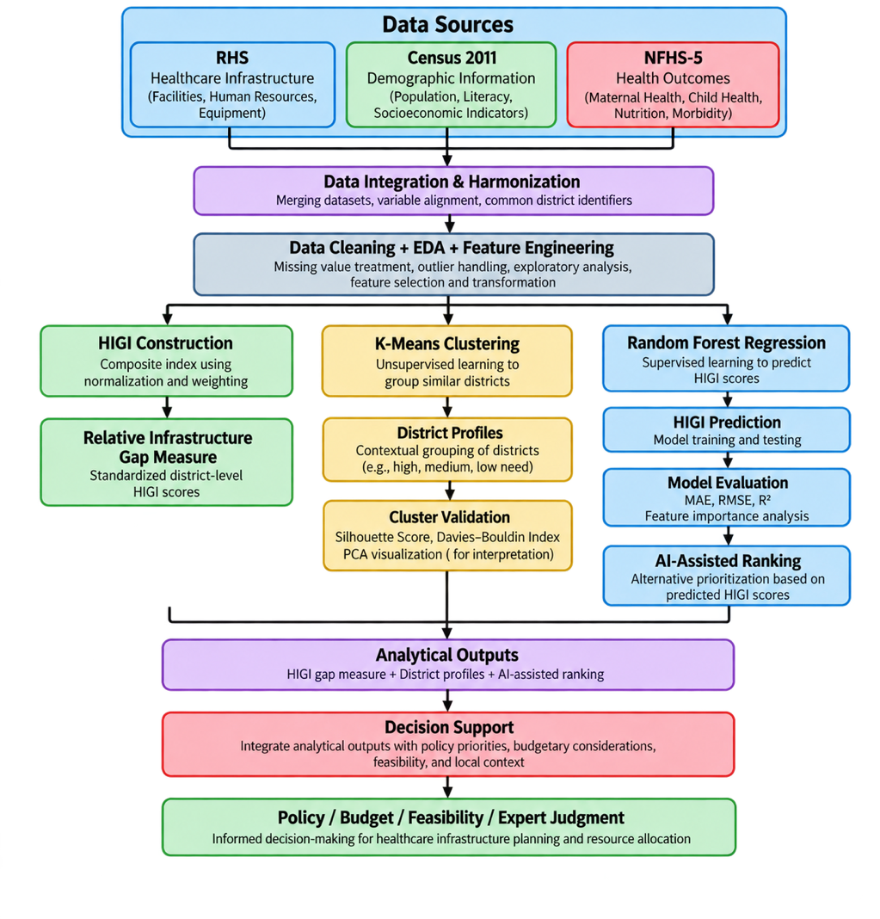
Figure 1: Architecture of AI-assisted Healthcare Infrastructure Gap Decision-Support Framework

AI and Machine Learning Methodology
Machine learning techniques were used to identify district profiles and provide an additional predictive perspective to healthcare infrastructure prioritization.
We used unsupervised learning, K-Means clustering, to identify districts with similar healthcare, demographic and health characteristics. The primary supervised model used to predict HIGI and to identify influential predictors was Random Forest regression. To assess if model optimization enhanced predictive performance, we compared models against a mean-based baseline and tuned hyperparameters.
The modeling workflow employed standardized features where appropriate and independent training and test data for independent model evaluation.

Table 14: Machine Learning Models and Their Purpose
Model | Purpose | Justification
K-Means Clustering | Group districts with similar healthcare, demographic, and health characteristics | Suitable for identifying district profiles without predefined classes
Baseline Regression | Establish a reference level of HIGI prediction performance | Provides a simple benchmark against which the Random Forest model can be evaluated
Random Forest Regression | Predict HIGI and identify influential predictors | Captures nonlinear relationships and provides feature-importance measures
Tuned Random Forest | Evaluate whether hyperparameter optimization improves model performance | Provides a robustness check through cross-validation and parameter optimization

Evaluation and Validation
Evaluation measures applicable for each method were used for model and analytical validation. Performance of Random Forest regression was assessed using MAE, RMSE and R2. Generalization was examined with held out test performance as well as with five-fold cross-validation, hyperparameter tuning was performed on the training data.
The quality of clusters for K-Means was evaluated using the Silhouette Score and DBI. The relationship between HIGI and some health indicators was explored using Spearman rank correlation.
We compared conventional HIGI rankings with rankings generated from Random Forest predictions for AI-assisted prioritization using Spearman rank correlation and Top-20 district overlap.

Evaluation Metrics
The following evaluation metrics were used to assess model performance, clustering quality, and ranking agreement.
Table 15: Evaluation Metrics Used in the Study
Metric | Purpose | Formula / Definition
Mean Absolute Error (MAE) | Average of prediction error for HIGI without considering the error direction | $$MEA= \frac{1}{n}* \sum{| y_{i}- \hat{y_{i}}|}$$
Root Mean Square Error (RMSE) | Prediction error measure that penalizes larger deviations more strongly | $$RMSE= \sqrt{\frac{1}{n}\sum_{i=1}^{n}{\left(y_{i}- {\hat{y}}_{i}\right)}}$$
R² | Measures the proportion of variance in HIGI explained by the model | $$R^{2}=1- \frac{\sum{{\left(y_{i}- {\hat{y}}_{i}\right)}^{2}}}{\sum{{\left(y_{i}- \overline{y}\right)}^{2}}}$$
Silhouette Score | Assesses the quality and separation of K-Means clusters | Compares within-cluster cohesion with the nearest-cluster separation; values closer to 1 indicate better separation
Davies–Bouldin Index | Assesses similarity between clusters | Lower values indicate better-separated and more compact clusters
Spearman Rank Correlation ((\rho)) | Measures agreement between ranked variables | Rank correlation between two variables; values closer to ±1 indicate stronger monotonic association
Top-20 Overlap | Measures agreement between the highest-priority districts identified by two ranking methods | $$\frac{Number of common districts in both Top-20 lists}{20}*100$$

For the completed analysis, MAE, RMSE, and R² were used for Random Forest regression; Silhouette Score and Davies–Bouldin Index were used for K-Means validation; and Spearman correlation together with Top-20 overlap was used to compare conventional HIGI and AI-assisted prioritization.

Mapping of Research Questions to Analytical Approach
The four research questions were mapped to the analytical methods implemented in the completed study. Table 15 summarizes the analytical approach and the principal output generated for each research question.
Table 16: Mapping of Research Questions to Analytical Approach
Research Question | Analytical Approach | Key Output
RQ1 | Data integration, district harmonization, data-quality assessment, and descriptive analysis | 488 districts × 18 variables integrated from RHS, Census 2011, and NFHS-5
RQ2 | Population normalization, HIGI construction, district ranking, and Spearman correlation analysis | District-level HIGI ranging from 0.0861 to 0.9765 and associations with selected health indicators
RQ3 | K-Means clustering, cluster validation, cluster profiling, and PCA visualization | 3 district profiles, with Silhouette = 0.2018 and Davies–Bouldin = 1.6442
RQ4 | Random Forest prediction, out-of-fold predictions, Spearman rank comparison, and Top-20 overlap analysis | ρ = 0.653, p < 0.001; 10% Top-20 overlap

The analytical approaches provide a structured basis for addressing each research question. Together, data integration, statistical analysis, composite-index construction, clustering, and machine learning enable assessment of healthcare infrastructure disparities and provide evidence to support district-level healthcare planning and prioritization.

Analysis

Data Cleaning
The integrated analytical dataset was subjected to a systematic data cleaning process to make sure of the data quality and consistency before analysis and modelling. The goal of this step was to find inconsistencies, confirm data types, look for missing values and ensure the integrity of the merged dataset.
The data integration preprocessing activities included district name harmonization, variable selection, data type validation, and duplicate record assessment and missing value analysis. These steps made sure that the final dataset was fit for statistical analysis and later modelling.
The final analytical dataset contained 488 districts and 18 variables on health infrastructure, demographic characteristics and health outcome indicators.
Table 17: Data Cleaning Summary
Data Cleaning Activity | Outcome
District name harmonization | Completed
Variable selection | Completed
Dataset integration | Completed
Duplicate record assessment | No duplicate records identified
Data type validation | Completed
Missing value assessment | Completed
Final analytical dataset | 488 districts × 18 variables

Missing Value Assessment
The integrated dataset was examined for missing observations across all variables. The assessment indicated that most variables contained complete information. Missing values were identified only in three health outcome variables.
Table 18: Missing Value Assessment
Variable | Missing Values
Full Immunization | 9
Stunting | 1
Underweight | 1
No missing values were observed in the healthcare infrastructure or demographic variables. Given the very small proportion of missing observations (less than 2% of the dataset), the missing values were retained for subsequent analysis without significantly affecting the overall integrity of the dataset.
Overall, the data cleaning process confirmed that the integrated dataset was of high quality and suitable for exploratory analysis and modelling.
The limited number of missing observations and the absence of duplicate records indicate that the dataset provides a reliable foundation for subsequent statistical analysis and machine learning.

Exploratory Data Analysis
EDA was conducted to understand the characteristics of the integrated analytical dataset and identify underlying patterns, relationships, and potential anomalies before statistical modelling. The analysis focused on evaluating data quality, summarizing the distribution of variables, examining relationships among healthcare infrastructure and health outcome indicators, and generating preliminary insights to support subsequent modelling.
The EDA comprised descriptive statistical analysis, missing value assessment, distribution analysis, and correlation analysis. The findings provide an overview of the district-level healthcare infrastructure landscape and establish the analytical foundation for the Healthcare Infrastructure Gap Index (HIGI).

Descriptive Statistics
Descriptive statistics was calculated to present the central, spread and range for each numeric variable included in the study. These statistics give a general idea of the variation that exists across the 488 districts.
The descriptive analysis indicates large differences across districts in availability of health care infrastructure, population characteristics and health outcomes. The large ranges of several variables indicate considerable regional variation and therefore warrant the need for a composite infrastructure index that can capture such variations.

Distribution Analysis
Distribution analysis was done to analyze the frequency distribution, variability and skewness of the selected variables. To explore the distributional properties of the data further, histograms were separately constructed for healthcare infrastructure and demographic and health outcome variables.
Healthcare Infrastructure Variables
The variables of health care infrastructure are positively skewed where majority of the districts were found to be having relatively lower number of health facilities while a few districts have a large number of health care infrastructure. This pattern suggests that there is a lot of disparity in the availability of health care infrastructure across districts.
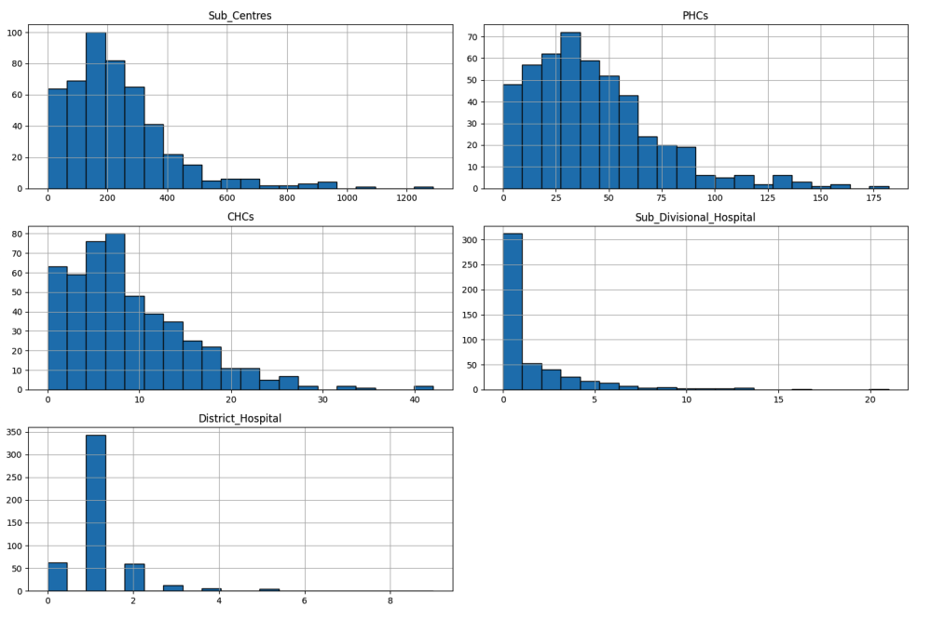
Figure 2: Distribution of Healthcare Infrastructure Variables
Demographic Variables
The demographic indicators are also characterized by different degrees of dispersion. Population variables show strong right skewness due to the presence of districts with high population density. Literacy related indicators show comparatively less variation. Such differences reflect the demographic heterogeneity across districts in India.
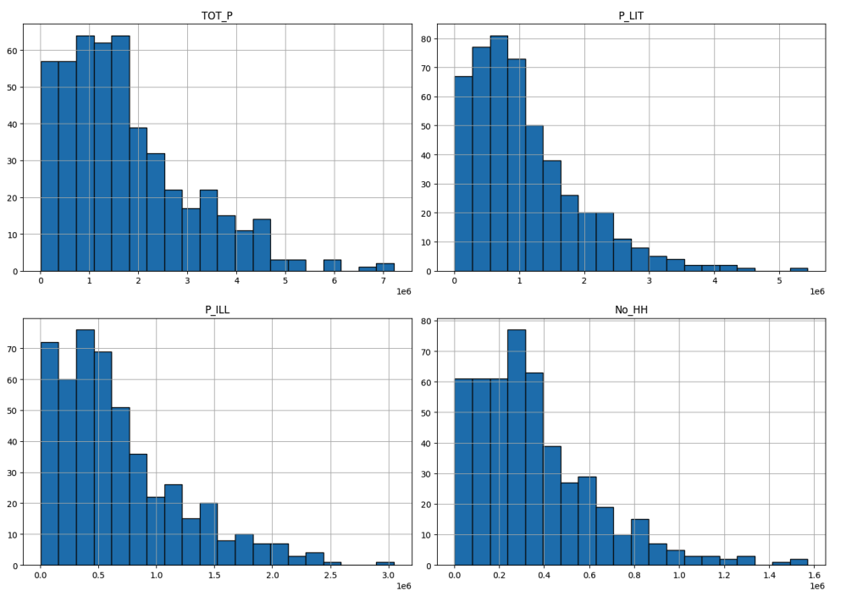
Figure 3: Distribution of Demographic Variables
Health Outcome Variables
In general, health outcome indicators have more concentrated distributions than infrastructure variables. Many districts have relatively high values for institutional births, skilled birth attendance and full immunization, while the wide variation observed in indicators such as stunting, underweight prevalence and women anemia suggests the persistence of disparities in maternal and child health outcomes.
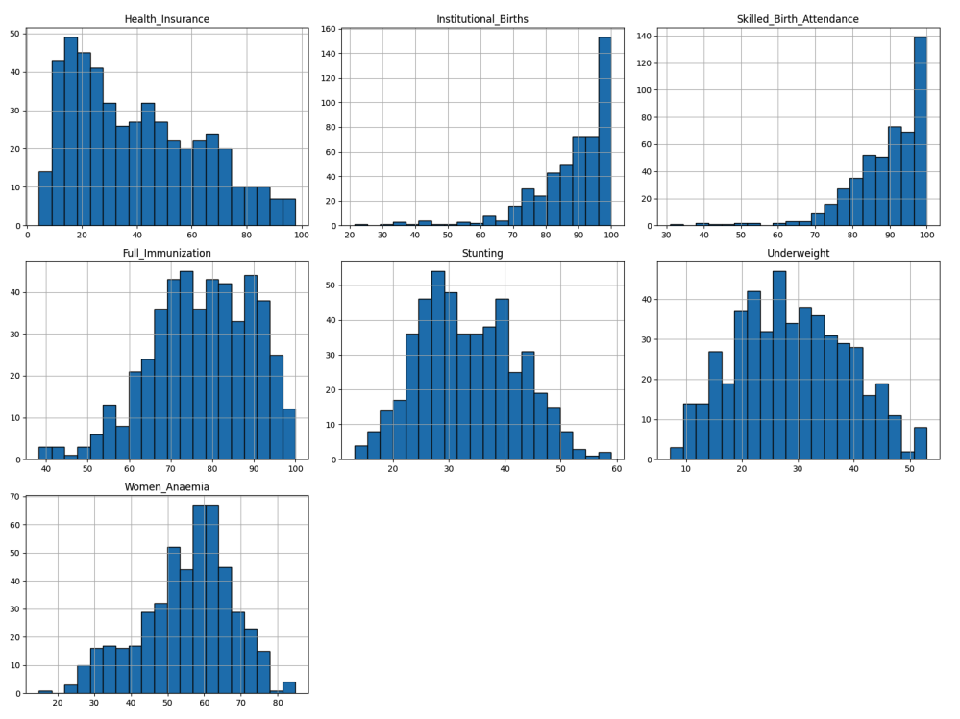
Figure 4: Distribution of Health Outcome Variables

Correlation Analysis
A Pearson correlation analysis was done to explore the relationship between healthcare infrastructure, demographic characteristics and selected health outcome indicators. The correlation matrix obtained gives an overall picture of the strength and direction of pairwise relationships between the variables included in the study.
The analysis shows a strong positive correlation among the variables of healthcare infrastructure such as Sub Centre, PHC, CHC and district population signifying that the districts with higher population generally have higher healthcare infrastructure capacity.
Healthcare infrastructure was also found to have a positive association with favorable health outcome indicators like Institutional Births and Skilled Birth Attendance. In contrast, Stunting and Underweight as negative health indicators have negative relationships with some of the healthcare infrastructure variables, meaning that better availability of healthcare may be associated with better maternal and child health outcomes.
Correlation analysis provides preliminary evidence supporting the study hypothesis that availability of healthcare infrastructure is associated with district-level health outcomes.
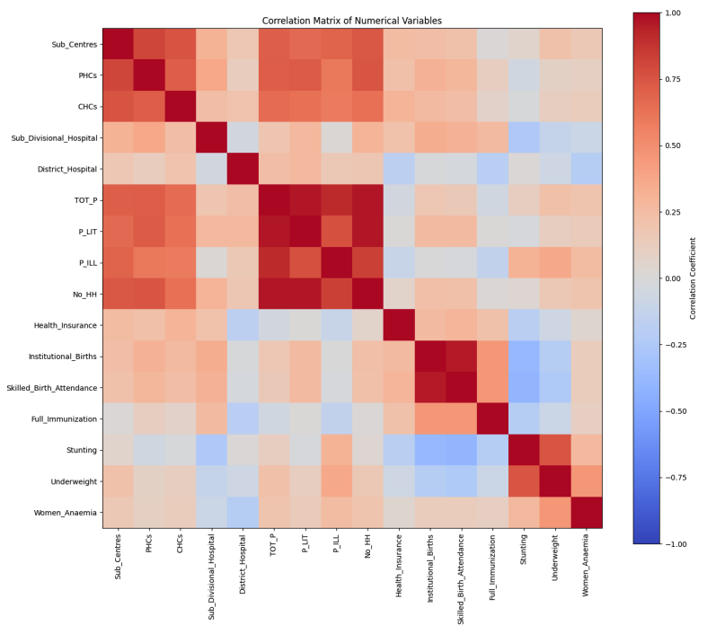
Figure 5: Correlation Matrix of the Integrated Analytical Dataset

Key Insights
The exploratory analysis produced several important findings that provide direction for the subsequent modelling phase:
- Considerable disparities exist in healthcare infrastructure availability across Indian districts.
- Population size is positively associated with the availability of healthcare facilities.
- Districts with better healthcare infrastructure generally exhibit improved maternal and child health indicators.
- Malnutrition indicators like Stunting and Underweight demonstrate negative associations with several healthcare infrastructure variables.
- The integrated dataset exhibits high data quality with minimal missing observations, making it suitable for statistical analysis and machine learning.
- The observed relationships provide a strong basis for constructing the Healthcare Infrastructure Gap Index (HIGI) and developing predictive models in the subsequent chapter.

Health Infrastructure Gap Index (HIGI)
We developed the Healthcare Infrastructure Gap Index (HIGI) as a standardized measure of relative healthcare infrastructure gaps at the district level. The index is based on the five indicators of healthcare infrastructure from RHS.
Due to the large variation of population size across districts, each infrastructure count was normalized to a measure per 100,000 population. To reduce the impact of unusually high values, extreme observations were clipped based on percentiles before normalization. The normalized infrastructure indicators were then equally aggregated to obtain the HIGI score for each district.
The obtained HIGI values are in the range of 0.0861 to 0.9765 in the analytical districts. Higher HIGI values indicate relative larger infrastructure gaps under the index formulation, whereas lower values indicate comparatively better infrastructure availability relative to the population.
The HIGI offers a single comparable measure that can be used to rank districts and identify areas for further assessment. It is intended to be a decision support indicator and not a direct measure of healthcare quality, service effectiveness or causal healthcare access.
Table 19: Top 10 Districts with Largest Infrastructure Gaps
District (State) | HIGI
Ghaziabad (UP) | 0.9765
Kancheepuram (TN) | 0.9763
Moradabad (UP) | 0.9684
Ahmadabad (GJ) | 0.9656
Faridabad (HR) | 0.9653
Vellore (TN) | 0.9621
Jalpaiguri (WB) | 0.9606
Raipur (CG) | 0.9604
Muzaffarnagar (UP) | 0.9600
Dhanbad (JH) | 0.9597

Table 20: Bottom 10 Districts with Smallest Infrastructure Gaps
District (State) | HIGI
Kinnaur (HP) | 0.0861
Anjaw (AR) | 0.2208
Tawang (AR) | 0.3282
Upper Siang (AR) | 0.3386
Shimla (HP) | 0.3605
Lower Dibang Valley (AR) | 0.3922
Dibang Valley (AR) | 0.4000
North District (SK) | 0.4111
Bilaspur (HP) | 0.4451
Mandi (HP) | 0.4486

HIGI Validation and Health Outcome Associations
Spearman rank correlation was used to check the association between HIGI and selected health outcome indicators.
Table 21: Spearman Correlation of HIGI with Selected Health Outcome Indicators
Indicator | Spearman ρ
Health Insurance | −0.348
Underweight | 0.312
Stunting | 0.260
Full Immunization | −0.246
Women Anaemia | 0.239
Institutional Births | −0.175
Skilled Birth Attendance | −0.147

The strongest association was observed between HIGI and health insurance coverage (ρ = −0.348), while underweight and stunting showed positive associations with HIGI. Full immunization also showed a negative association. These relationships indicate that districts with different levels of relative infrastructure gaps also exhibit systematic differences in selected health indicators.
These findings support the use of HIGI as a comparative infrastructure-gap measure, while the associations interpreted as relationships instead of causal effects.

District Clustering: RQ3
K-Means clustering was applied to identify districts with similar healthcare infrastructure, demographic, and health characteristics. Standardized variables were used so that differences in measurement scales did not dominate the clustering process.
The analysis identified three district profiles. Cluster quality was checked using the Silhouette Score and DBI.
Table 22: Cluster Validation Results
Measure | Result
Number of Clusters | 3
Silhouette Score | 0.2018
Davies–Bouldin Index | 1.6442

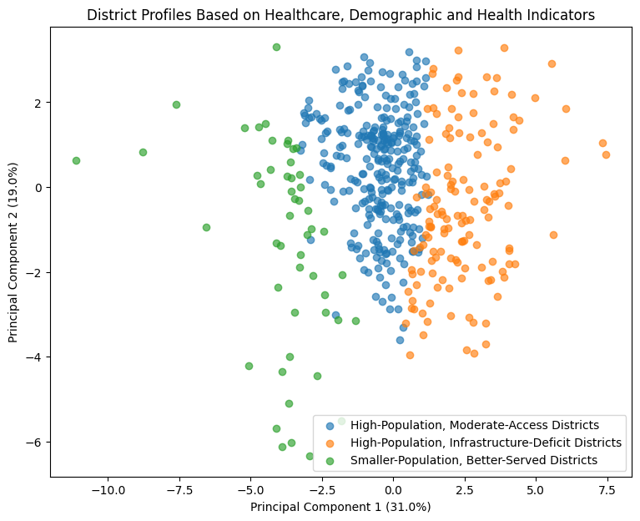
Figure 6:PCA Visualization of District Profiles Based on Healthcare, Demographic and Health Indicators
The PCA visualization shows the distribution and overlap of the three district profiles. The modest clustering separation indicates that the groups represent useful analytical profiles rather than sharply distinct categories.

Predictive Modelling
A mean-based baseline and Random Forest regression were evaluated for predicting HIGI. The dataset was divided into 383 training observations and 96 test observations.
Table 23: Model Performance Comparison
Model | MAE | RMSE | R²
Baseline | 0.0990 | 0.1429 | -0.0013
Random Forest | 0.0524 | 0.0770 | 0.7092
Tuned Random Forest | 0.0529 | 0.0773 | 0.7073

The Random Forest substantially outperformed the baseline, reducing MAE and RMSE while achieving an R² of 0.7092. Hyperparameter tuning produced only a marginal cross-validation improvement and slightly weaker independent test performance; therefore, the original Random Forest was retained as the final model.
Feature Importance
P_ILL was the most important predictive feature, followed by TOT_P, Health Insurance, and Full Immunization. This indicates that demographic scale and selected health-related characteristics contribute meaningfully to variation in predicted HIGI.
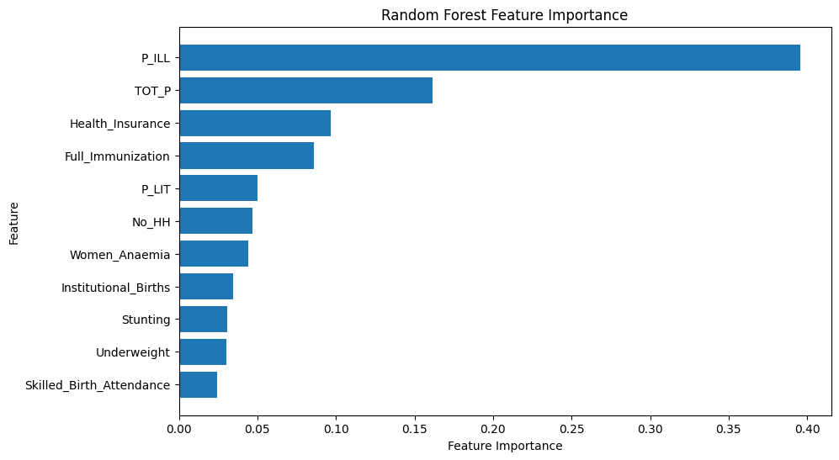
Figure 7: Random Forest Feature Importance
The model captures the overall relationship between the predictors and HIGI, although prediction error remains for some lower-HIGI observations.
This analysis supports the use of Random Forest as the final predictive model and provides the modelling evidence used in the subsequent AI-assisted prioritization analysis.

AI-Assisted District Prioritization: RQ4
To assess the value of the AI-assisted approach, district rankings based on observed HIGI scores were compared with rankings generated from Random Forest predictions. The predictions ensure that each district's prediction was generated without using that observation during model training.
The two rankings showed a moderate positive association:
- Spearman ρ = 0.653
- Top-20 district overlap = 2 districts (10%)
The moderate rank correlation indicates overall agreement between the two approaches, while the low top-20 overlap shows that the AI-assisted approach identifies a substantially different set of highest-priority districts.
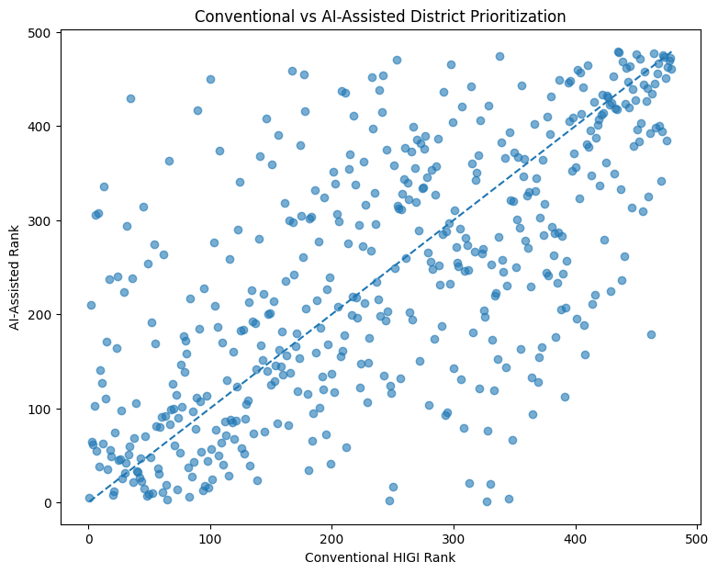
Figure 8: Comparison of Conventional HIGI and AI-Assisted District Prioritization
The results suggest that the AI-assisted approach provides a complementary prioritization perspective rather than simply reproducing the conventional HIGI ranking. The analysis does not establish that the AI-assisted approach is superior to HIGI-based prioritization; instead, it demonstrates its potential to provide an additional evidence base for district-level decision-making.

Summary of Results by Research Question
Table 24: Summary of Research Findings
Research Question | Analytical Approach | Key Result | Finding
RQ1 | Data integration and harmonization | 488 districts × 18 variables successfully integrated | The RHS, Census 2011, and NFHS-5 datasets were successfully integrated into a common district-level analytical dataset.
RQ2 | HIGI construction, ranking and health-outcome association analysis | HIGI range: 0.0861–0.9765; strongest association with Health Insurance: ρ = −0.348 | HIGI provides a standardized basis for comparing relative infrastructure gaps across districts and shows meaningful associations with selected health outcomes.
RQ3 | K-Means clustering + cluster validation + PCA | 3 district profiles; Silhouette = 0.2018; Davies–Bouldin = 1.6442 | Districts can be grouped into interpretable profiles, although cluster separation is moderate.
RQ4 | Random Forest + out-of-fold ranking comparison | ρ = 0.653, p < 0.001; Top-20 overlap = 10% | AI-assisted prioritization provides a complementary perspective and identifies substantially different high-priority districts from conventional HIGI ranking.

Overall, the analysis supports the use of integrated district-level data, HIGI, clustering, and machine learning as complementary tools for healthcare infrastructure assessment and prioritization.
The findings support a decision-support role for the framework rather than positioning it as a substitute for policy or expert judgement.

Recommendation and Application
The completed analysis provides a data-driven framework that can support district level healthcare infrastructure planning. The framework combines the HIGI score, district profiles, and Random Forest predictions to provide multiple perspectives for identifying districts that may require further assessment and infrastructure attention.

Practical Application
The framework can support decision-makers in a staged prioritization process:
- Identify districts with relatively larger infrastructure gaps using HIGI rankings.
- Review district profiles from the clustering analysis to understand differences in population, infrastructure availability, and health characteristics.
- Use the AI-assisted ranking as a complementary signal to identify districts that may warrant additional review.
- Combine these analytical outputs with local context, feasibility, budget availability, and policy priorities before making investment decisions.
The framework is therefore intended to support, rather than automate, healthcare infrastructure allocation decisions. It can provide a common analytical basis for comparison across districts while retaining the role of policymakers and officers incharge in final decision-making.
The analysis demonstrates that AI-assisted prioritization offers a complementary perspective, with a Spearman correlation of 0.653 with conventional HIGI ranking but only 10% overlap among the top 20 districts.

Business Interpretation
The results indicate that from a planning perspective, the gaps in healthcare infrastructure cannot be effectively evaluated through a single dimension. Districts are on a very different scale in terms of population, availability of infrastructure and selected health indicators. A combined analytical view is useful for prioritization.
The clustering results offer another view of segmentation by identifying three district profiles. This can help planners identify high-population districts with infrastructure constraints and smaller districts with relatively better infrastructure profiles. Moreover, the predictive model provides an alternative means of ranking other than just mirroring the HIGI ranking.
So the framework has value as a decision-support mechanism: HIGI could provide the main infrastructure-gap signal, clustering could provide context segmentation, and machine learning could provide an alternative prioritization perspective.

Risks and Mitigation
Table 25: Risks and Mitigation
Risk | Potential Impact | Mitigation
Data from different years | District conditions may not be fully comparable at a single point in time | Refresh the framework as newer official datasets become available and interpret results with temporal differences in mind
HIGI is a relative measure | A high score does not automatically imply poor service quality or implementation failure | Use HIGI as a screening and comparison tool alongside operational and clinical indicators
Model overfitting | Predictions may perform less effectively on unseen districts or future data | Use held-out testing, cross-validation, and periodic model revalidation
Low top-20 overlap between methods | Different approaches may produce different investment priorities | Treat AI ranking as a complementary signal and require policy/expert review before allocation
Missing or incomplete indicators | District rankings may be affected by data limitations | Maintain data-quality checks and document missingness before each analysis cycle
Policy or feasibility constraints | Analytical priority may not always be actionable | Incorporate budget, geography, staffing, implementation feasibility, and policy priorities into final decisions

Significance of the study
This study demonstrates the potential of utilizing publicly available government datasets along with statistical and machine learning techniques to enable district-level healthcare infrastructure assessment in India.
The framework makes three contributions. First, the Healthcare Infrastructure Gap Index (HIGI) provides a standardized yardstick to compare relative infrastructure gaps across districts. Second, district clustering offers interpretable profiles that complement infrastructure comparisons with demographic and health context. Third, the Random Forest model gives a different viewpoint for prediction in the prioritization of districts.
From a practical standpoint, the framework can act as a guide for policymakers and healthcare administrators in moving from isolated indicators to a more systematic, evidence-based assessment process. The results also suggest that AI-assisted prioritization should be considered as a complementary analytical input, rather than a substitute for conventional measures or expert judgment.
From an academic perspective, this project demonstrates the application of data analytics and AI techniques to a real-world public healthcare planning problem using secondary government data. The overall approach may also be a methodological reference for similar evidence-based resource-allocation problems in other public-sector domains.

Limitations of the Study
The project has the following limitations:
- Data vintage: This project combines datasets collected in different periods, including Census 2011, NFHS-5, and, RHS. These temporal differences may affect comparability and interpretation.
- Data coverage: The framework relies on publicly available district-level data and does not include private healthcare infrastructure, real-time healthcare information, individual patient records, or detailed facility-level operational measures.
- HIGI interpretation: HIGI is a relative infrastructure-gap measure and not be interpreted as a direct measure of healthcare quality, service effectiveness, or causal healthcare access.
- Model limitations: The Random Forest shows some difference between training and test performance, indicating a degree of overfitting. The AI-assisted ranking should therefore be treated as a complementary analytical signal rather than a definitive priority ranking.
- Generalizability: Results are specific to the selected Indian districts, variables, and data sources and may not directly generalize to other countries or healthcare systems.
- Decision context: The framework does not incorporate budget constraints, implementation feasibility, geographic accessibility, staffing availability, or other policy considerations that may influence actual investment decisions.

Conclusion
This study developed and evaluated an AI-enabled decision-support framework to assess and prioritize gaps in healthcare infrastructure across Indian districts. The study constructed an analytical dataset at district level with 488 districts and 18 variables by combining data from the three source datasets. The integrated dataset provided a common platform for infrastructure, demographic characteristics and health outcomes.
The Healthcare Infrastructure Gap Index (HIGI) was a standardized measure of relative infrastructure gaps across districts. The observed values of the index varied from 0.0861 to 0.9765. Association analysis revealed significant relations between HIGI and some health indicators, and clustering analysis distinguished three district profiles with moderate separation.
Random Forest regression was shown to outperform the baseline model with a test R² of 0.7092, MAE of 0.0524 and RMSE of 0.0770. We identified a moderate correlation between the AI-assisted prioritization analysis and the traditional HIGI ranking (Spearman ρ = 0.653, p < 0.001), but only 10% of the top 20 districts were the same, indicating that the predictive approach provides a different yet complementary lens of prioritization.
Overall, the findings suggest that integrated analytics, composite indicators, clustering and machine learning can offer a useful evidence base for healthcare infrastructure planning at the district level. The framework is most useful as a decision support tool, combining analytical evidence with rather than replacing policy priorities, implementation feasibility and expert judgment.

References
International Institute for Population Sciences (IIPS), & ICF. (2021). National family health survey (NFHS-5), 2019–21: India. IIPS.
James, G., Witten, D., Hastie, T., & Tibshirani, R. (2021). An introduction to statistical learning: With applications in R (2nd ed.). Springer.
Ministry of Health and Family Welfare. (2022). Rural health statistics 2021–22. Government of India.
Mukherji, A., Rao, M., Desai, S., Subramanian, S. V., Kang, G., & Patel, V. (2024). District-level monitoring of universal health coverage, India. Bulletin of the World Health Organization, 102(9), 630–638B.
Office of the Registrar General & Census Commissioner, India. (2011). Census of India 2011. Government of India.
Organisation for Economic Co-operation and Development, & Joint Research Centre. (2008). Handbook on constructing composite indicators: Methodology and user guide. OECD Publishing.
Russell, S., & Norvig, P. (2021). Artificial intelligence: A modern approach (4th ed.). Pearson.
Sehgal, M., Jatrana, S., & Johnson, L. (2024). A comprehensive health index for India: Development, validation, and spatial variation. Journal of Population Research, 41, Article 21.
Sharda, R., Delen, D., & Turban, E. (2023). Business intelligence, analytics, data science, and AI: A managerial perspective (5th ed.). Pearson.
Sharma, A., Prinja, S., & Aggarwal, A. K. (2017). Measurement of health system performance at district level: A study protocol. Journal of Public Health Research, 6(3), Article 917. https://doi.org/10.4081/jphr.2017.917
Sharma, A., Prinja, S., & Aggarwal, A. K. (2019). Comprehensive measurement of health system performance at district level in India: Generation of a composite index. The International Journal of Health Planning and Management, 34(4), e1783–e1799.
Sivasubramanian, S., & Raval, A. (2025). Artificial intelligence–augmented public health interventions in India. Health Affairs Scholar, 3(5)
Saragadam, S. K., Saragadam, S. H., Kumari, K. S. S., & Kasturi, G. V. K. (2025). Explainable machine learning on health management information system data to unveil health factors affecting maternal mortality ratio of districts in India towards achieving sustainable development goals. Journal of Information Systems Engineering and Management, 10(24s).

